Project Design Phase-II Technology Stack (Architecture & Stack)

Date | 27 January 2026
Team ID | LTVIP2026TMIDS36395
Project Name | Automated Car Catalog System For Enhanced  Showroom Management
Maximum Marks | 4 Marks

Technical Architecture:
The Car Catalog System – Mahendra Showroom is designed on the ServiceNow platform to automate and streamline the cataloging and booking of cars through a digital showroom experience. The architecture is based on cloud deployment with ServiceNow's native application logic, table extensions, workflow engine, and service portal. The platform provides role-based access control, user and task management, and dynamic email notifications.
The architecture includes:
- A Web UI (Service Portal) for interaction
- ServiceNow Application logic (catalog setup, workflows, notifications)
- Table-based data storage
- Role-based access and group control
- Notification engine
Infrastructure is entirely cloud-based on the ServiceNow environment.

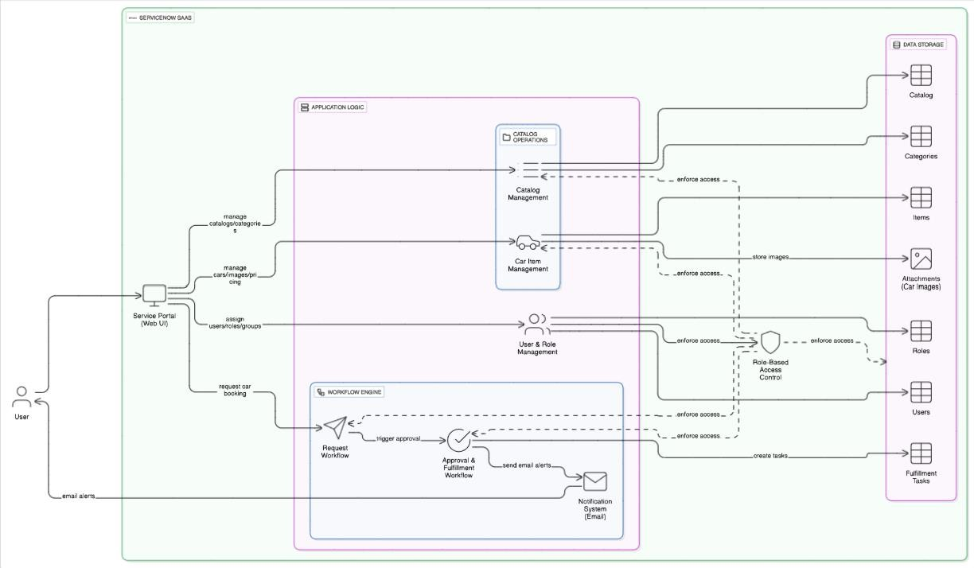

Table-1 : Components & Technologies:

S.No | Component | Description | Technology
1. | User Interface | Users access the catalog via a web interface. | ServiceNow Service Portal  (HTML, JS)
2. | Application Logic-1 | Catalog creation, category setup, item  addition. | ServiceNow Flow Designer /  Server Scripts
3. | Application Logic-2 | Workflow creation for approvals and tasks. | Workflow Editor (Graphical  Designer)
4. | Application Logic-3 | Email notifications for booking  approval/rejection. | Notification Engine + HTML  Templates
5. | Database | Stores catalog, users, items, and request  data. | ServiceNow Tables (Custom +  Core Tables)
6. | Cloud Database | Native ServiceNow table storage in cloud. | ServiceNow Platform Storage
7. | File Storage | Image files for cars added during catalog item creation. | ServiceNow Attachment Handling
8. | External API-1 | Not applicable in this phase. | N/A
9. | External API-2 | Not applicable in this phase. | N/A
10. | Machine Learning Model | Not applicable in this phase, may be explored for future recommendations. | N/A
11. | Infrastructure (Server / Cloud) | Fully cloud-based ServiceNow  deployment. | ServiceNow Cloud Instance

Table-2: Application Characteristics:

S.No | Characteristics | Description | Technology
1. | Open-Source Frameworks | ServiceNow uses internal proprietary tools; UI supports web standards  (HTML/CSS/JS). | Web Standards
2. | Security Implementations | Role-based access, permission lists, and user group restrictions in ServiceNow. | RBAC, ACLs, Encryption (at rest/in transit)
3. | Scalable Architecture | Scalable via ServiceNow’s multi-instance  cloud architecture. | 3-tier layered on ServiceNow
4. | Availability | ServiceNow cloud offers high availability and redundancy. | Cloud Infrastructure (SLA-backed uptime)
5. | Performance | Optimized workflows, table indexing, and  ServiceNow caching improve performance. | GlideRecord APIs, Indexes,  Caching

